**NAME**

**JAHNZAIB ZAFAR**

**SECTION**

**BS ARTFICIAL INTELLIGENCE– 3B**

**TASK (6)**

**PART NUMBER 1**

**Output**

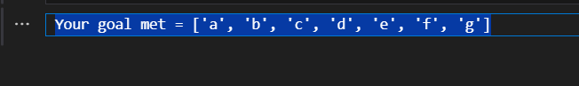

**EXPLANATION**

* A class BFS is created to implement the **Breadth-First Search** algorithm.
* In the constructor :
  + **self.tree** stores the graph or tree structure.
  + **self.visited** keeps track of visited nodes.
  + **self.queue** manages the nodes to be explored (FIFO order).
* The method **search(start, goal)** begins the search by adding the **start node** to the queue.
* A **while loop** runs as long as the queue is not empty.
* In each iteration:
  + The first element is removed from the queue using **pop(0)** (FIFO).
  + If this node is not visited, it is added to the visited list.
* The algorithm checks if the current node is the **goal**:
  + If yes, it prints the visited nodes and stops.
  + If not, it continues searching.
* All **neighbors (child nodes)** of the current node are added to the queue.
* The process repeats until the goal is found or the queue becomes empty.

**PART NUMBER TWO**

* In which case ,I have no use the classes
* In which there is same implementation of queue like in the classes system but not use queue in this code